Multiple-choice section – choose the correct answer

Question 1 [7.1]

‘Two less than three times a number gives a solution of eight’ is:

A 3*n* − 2 = 8 B 2 − 2*n* = 8 C 3(*n* − 2) = 8 D 3(2 − *n*) = 8

Question 2 [7.1]

Use substitution to find the value of *a* in4*a* + 5 = -11

A *a* =  B *a* = -4 C *a* = -24 D *a* = 4

Question 3 [7.2]

What is the value of *y* where *x* = -1?

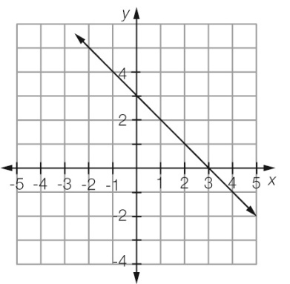

A *y* = 0 B *y* = 3 C *y* = 4 D *y* = 2

Question 4 [7.2]

From the graph in Question 3, what is the value of *x* where *y* = 0?

A *x* = 0 B *x* = -3 C *x* = 2 D *x* = 3

Question 5 [7.2]

To obtain *x* from  + 5 you would:

A add 5 and divide by 4 B subtract 5 and divide by 4

C add 5 and multiply by 4 D subtract 5 and multiply by 4

Question 6 [7.4]

The solution of the balance diagram is:

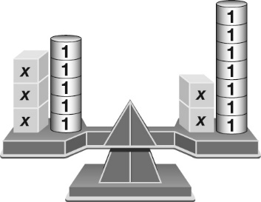

A *x* = 2 B *x* = -2 C 4*x* = 3*x* − 2 D *x* = 3

Question 7 [7.3]

Solve  − 3 = 5

A *b* =  B *b* = 10 C *b* = 40 D *b* = 

Question 8 [7.3]

Solve 2(*x* − 3) = 14

A *x* = 4 B *x* = 10 C *x* = 16 D *x* = 14

Question 9 [7.4]

Solve 3*d* + 2 = 5*d* − 26

A *d* = 14 B *d* = 4 C *d* = 12 D *d* = 

Question 10 [7.5]

Anna buys five ice-creams and gets 50 cents change from $10.00. How much was each ice-cream?

A $1.10 B $1.40 C $1.90 D $1.15

Multiple-choice results: ___ /10

Short answer section

Question 11 3 marks [7.3]

Here is Eleanor’s working to solve the equation  – 5 = 7. She has made an error.

Eleanor’s working Correct working

 = 9

 = 15

5*x* = 30

*x* = 6

(a) Circle the line of working where the error appears.

(b) Write the correct working for the question in the space next to Eleanor’s working.

(c) Briefly explain where Eleanor went wrong in the calculation.

Question 12 3 marks [7.2]

This graph describes the volume of water in a bucket that has a leak in it.

Using specific examples from the graph, write a sentence to describe how the volume of water changes in the bucket.

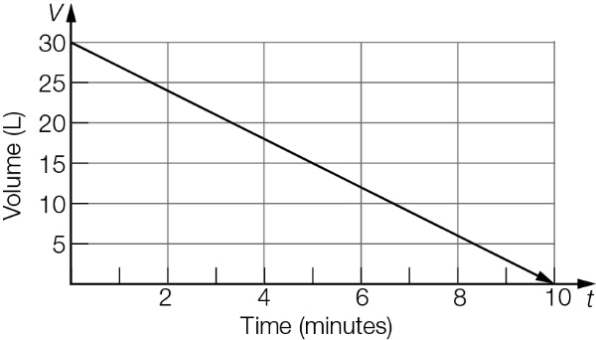

Question 13 2 marks [7.1]

Write an equation for each of the following.

(a) A number is doubled and then has 12 taken from it. The result is 40.

(b) The product of three and a number has 6 added to it. The result is the same as doubling the number and increasing by fifteen.

Question 14 4 marks [7.1]

Check by substitution whether the number in the brackets is a solution for the equation.

(a) 4*x* − 3 = 9 (*x* = 3) (b) = 18 (*x* = 3)

Question 15 2 marks [7.1]

Using words only, write a sentence that fits the equation.

2*y* − 7 = 14

Question 16 2 marks [7.1]

Write an equation for each of these rules, using the given pronumerals for each of the   
quantities described.

(a) Time (*t*) is equal to the distance (*d*) times the speed (*s*).

(b) Velocity (*v*) is equal to the initial speed (*u*) plus the acceleration (*a*) multiplied by   
the time (*t*).

Question 17 2 marks [7.2]

Use the diagram to calculate the value of *x*.



Question 18 4 marks [7.2]

Solve each of these linear equations using algebra.

(a) 3*b* + 2 = 14 (b) 13 + 4*d* = -27

Question 19 4 marks [7.2]

Use the following graph to find the value of:

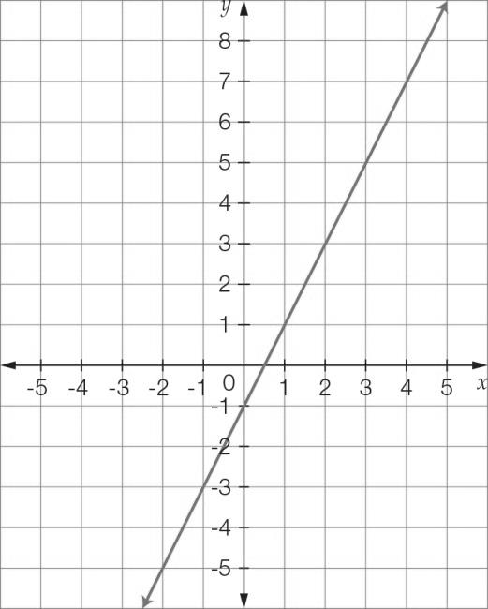

(a) *y* where *x* = 1 (b) *y* where *x* = 4

(c) *x* where *y* = 5 (d) *x* where *y* = -1

Question 20 4 marks [7.2]

Solve each of these linear equations using algebra.

(a) 4*a* − 5 = -17 (b)  + 2*x* = 

Question 21 3 marks [7.2]

Sarah buys a sandwich from the canteen every day at school. Last week she also bought orange juice for $2.50 on two of the days. Her bill for last week was $20.

(a) Write an algebraic expression to represent this statement.

(b) What is the cost of a sandwich?

Question 22 6 marks [7.3]

Solve the following equations involving fractions.

(a)  = 7 (b)  + 7 = 3

Question 23 6 marks [7.3]

Solve each of the following equations.

(a) 2(*x* − 3) = 16 (b) 3(5*x* + 2) = 51

Question 24 6 marks [7.3]

Write the following statements as equations and then find the value of the unknown.

(a) The product of a number and six has five added to it. The result is seventeen. What is   
the number?

(b) The quotient of a number and five has seven added to it. The result is ten. What is the number?

Question 25 4 marks [7.3]

James uses 100 cm of string to tie up a box that is the shape of a cube. The string goes around the box twice and 20 cm is used to tie the bow on the top.



(a) Write an equation to represent this information.

(b) Use the equation find the width of the box.

Question 26 3 marks [7.4]

Use the diagram to calculate the value of *x*.

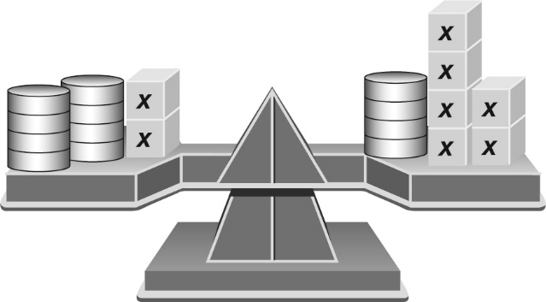

Question 27 6 marks [7.4]

Solve the following equations using algebra.

(a) 6*x* − 5 = 4*x* + 5 (b) 2*x* + 1 = 5*x* − 14

Question 28 6 marks [7.4]

Solve the following equations using algebra.

(a) 5*x* − 2 = 3(*x* + 8) (b) 4(*x* + 4) = 3(2 − 2*x*)

Question 29 6 marks [7.4]

Solve the following equations using algebra.

(a)  =  (b)  = 

Question 30 6 marks [7.4]

Solve the following equations graphically by finding the point of intersection of the graphs listed.

(a) 3 − *x* = 2*x* (b) 2*x* − 3 = 3 − *x*

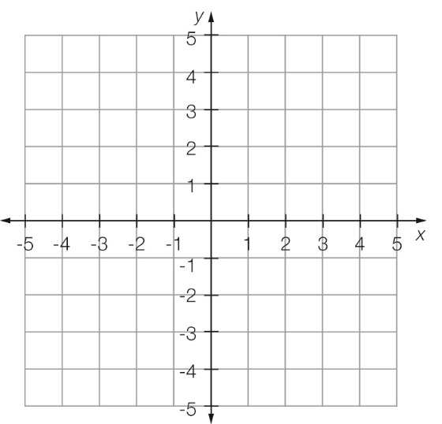 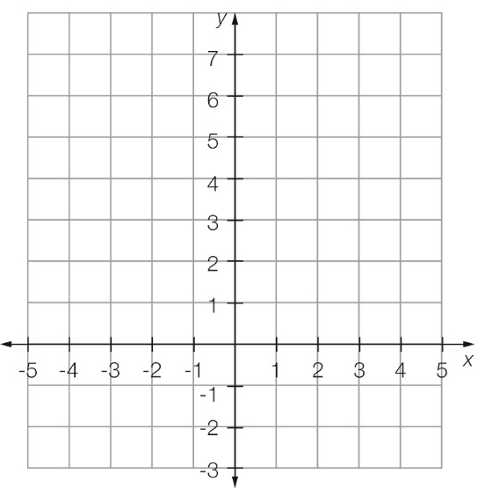

Short answer results: ___ / 82

Extended answer section

Question 31 5 marks [7.2, 7.5]

Aya has a mobile phone plan that provides $600 of SMS and calls each month. Each month it costs $50 plus the cost of any additional SMS and calls over the $600 covered by the plan.

SMS cost 25 cents each and calls cost $0.60 plus 15 cents per 10 seconds.

(a) Write an equation for the cost of a call $*C* that is *n* minutes long. (Note that she is charged by the 10-second interval.)

(b) What is the cost of a call that is 8 minutes long?

(c) What is the cost of 7 calls with a total time of 67 minutes?

(d) One month Aya has calls with a total cost of $385 and sends a total of 993 texts. What is her bill for this month?

Question 32 10 marks [7.3, 7.5]

A pool is three times as long as it is wide. The pool is enclosed by a fence, which is 4 m from each side of the pool, as shown in the diagram. The width of the pool is *w* metres.

(a) Clearly label the measurements in terms of *w* on the diagram below.

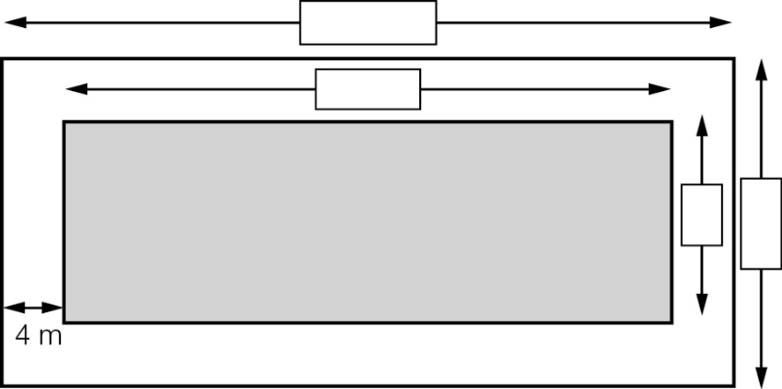

(b) Write an equation for the perimeter (*P*) of the fence.

(c) If the pool can be fenced with 96 m of fencing, what are the dimensions of the pool?

(d) Entry to the pool is $1.50 for children and $3.50 for adults. On a particular day 300 people attend the pool. There are twice as many children as adults.

(i) Write an expression for the number of adults at the pool and hence calculate the number of adults at the pool.

(ii) Calculate the total amount of money collected in entry fees.

Extended answer results: ___ / 15

TOTAL test results: ___ / 107